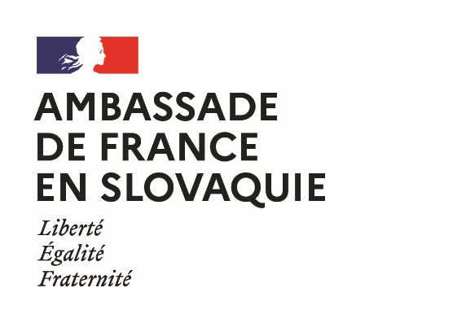 | 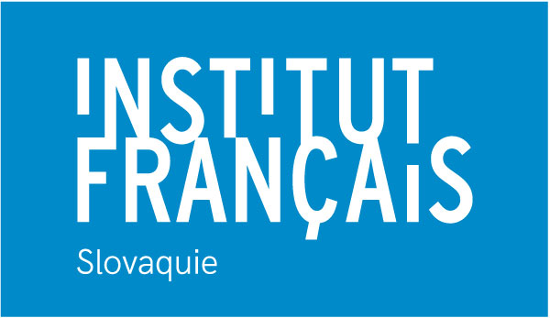 | 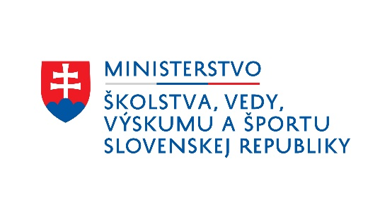

French Government Fellowships
2022 edition
Application for doctoral studies in joint supervision
Last name and first name:
Gender:
Nationality or nationalities:
Date of birth:
Place of birth:
Phone number:
E-mail address:
Postal address:

- I give my consent for the Academic and Scientific Service of the French Embassy in Slovakia to process my data and transmit them to its partners (CampusFrance, Ministry of Education of the Slovak Republic and Slovak Academic Information Agency) in order to select the beneficiaries of its scholarship program, to organize their study trips and, if a scholarship is awarded to them, to ensure their implementation
- I give my consent for the University and Scientific Service of the French Embassy in Slovakia to register my details and to use them for the purpose of sending me information concerning studies in France and French-Slovak university cooperation.
Date: Signature:

Title of the thesis project:

In Slovakia:
host institution:

name and e-mail address of co-supervisor:

En France :
host institution:

name and e-mail address of co-supervisor:

Please attach to this application form, in either English or French:
- a curriculum vitae presenting all information relevant to the evaluation of your application (e.g. education, professional experience, other activities, languages spoken and proficiency level, experience with life abroad, research activity);
- a presentation of your research project (maximum two pages), indicating the context, the methodology, the expected results;
- a letter of motivation (maximum two pages), justifying the choice of the research topic, of a co-supervision, and the professional project;
- two letters of support for the application, one from each of the two thesis co-directors, explicitly mentioning the research topic and the aded value of a co-supervision;
- a copy of your diplomas;
- a copy of your transcripts from the last two years.
Additional letters of support may optionally be attached to the application.

The application may be submitted electronically, by mail, or filed by March 1, 2022 to:
Mme Martina SAGANOVÁ,
Institut français de Slovaquie,
Sedlárska 7, 812 83 BRATISLAVA,
Tel. : +421 (0)2 59 34 77 41
Email : martina.saganova@institutfrancais.sk

