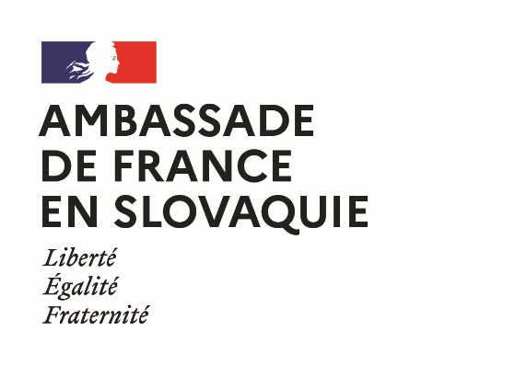 | 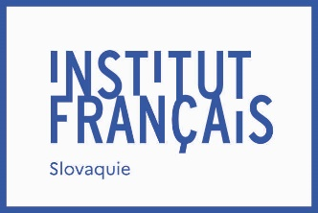 | 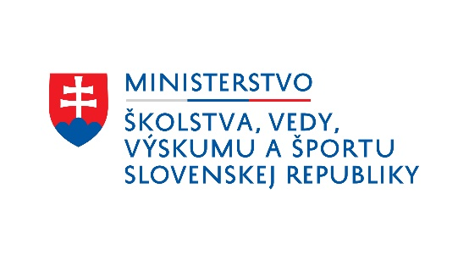

French Government Fellowships
2023 edition
Application for a French+Sciences fellowship
Last name and first name:
Gender:
Nationality or nationalities:
Date of birth:
Place of birth:
Phone number:
E-mail address:
Postal address:

- I give my consent for the Academic and Scientific Service of the French Embassy in Slovakia to process my data and transmit them to its partners (Campus France, Ministry of Education of the Slovak Republic and Slovak Academic Information Agency) in order to select the beneficiaries of its scholarship program, to organize their study trips and, if a scholarship is awarded to them, to ensure their implementation
- I give my consent for the University and Scientific Service of the French Embassy in Slovakia to register my details and to use them for the purpose of sending me information concerning studies in France and French-Slovak university cooperation.
Date: Signature:

Program for which the scholarship is requested :

Please attach to this application form, in electronic format and in English:
- a cover letter presenting your interest in the programme as well as your study and/or professional plans;
- a curriculum vitae.

Letters of support (e.g. from your teachers) may optionally be attached to the application.

The application may be submitted electronically, by mail, or filed by March 20, 2023 to:
Mme Martina SAGANOVÁ,
Institut français de Slovaquie,
Sedlárska 7, 812 83 BRATISLAVA,
Tel. : +421 (0)2 59 34 77 41
Email : martina.saganova@institutfrancais.sk

