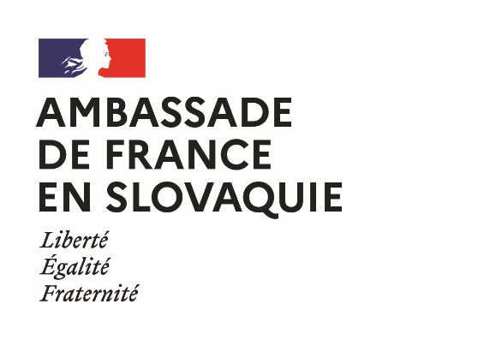 | 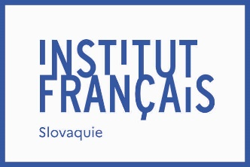 | 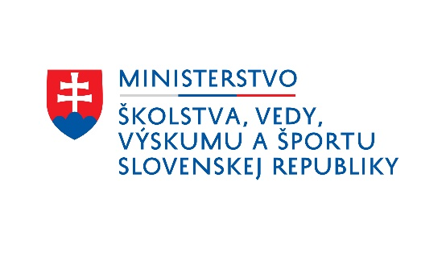

French Government Fellowships
2023 edition
Application at the Master 2 level
Last name and first name:
Gender:
Nationality or nationalities:
Date of birth:
Place of birth:
Phone number:
E-mail address:
Postal address:

- I give my consent for the Academic and Scientific Service of the French Embassy in Slovakia to process my data and transmit them to its partners (CampusFrance, Ministry of Education of the Slovak Republic and Slovak Academic Information Agency) in order to select the beneficiaries of its scholarship program, to organize their study trips and, if a scholarship is awarded to them, to ensure their implementation
- I give my consent for the University and Scientific Service of the French Embassy in Slovakia to register my details and to use them for the purpose of sending me information concerning studies in France and French-Slovak university cooperation.
Date: Signature:

Training course(s) for which the scholarship is requested :
- choice number 1
institution:

title of the program of study :

name and e-mail address of the program supervisor:

- choice number 1
institution:
title of the program of study :
name and e-mail address of the program supervisor:

Please attach to this application form, in electronic format, in either English or French, depending on the teaching language of the program for which the grant is requested:
- a curriculum vitae presenting all information relevant to the evaluation of your application (e.g. education, professional experience, other activities, languages spoken and proficiency level, experience with life abroad);
- a presentation of your professional and study project (maximum two pages);
- a copy of your diplomas;
- a copy of your transcripts from the last two years (at school or university);
- for applicants who are already enrolled in a higher education institution (does not apply to high school students): an acceptance letter, or proof of contact with the French institution.
Letters of support may optionally be attached to the application.

The application may be submitted electronically, by mail, or filed by March 30, 2023 to:
Mme Martina SAGANOVÁ,
Institut français de Slovaquie,
Sedlárska 7, 812 83 BRATISLAVA,
Tel. : +421 (0)2 59 34 77 41
Email : martina.saganova@institutfrancais.sk

