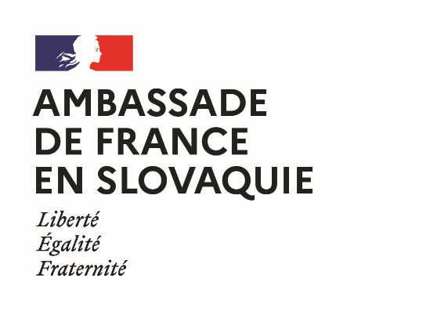 | 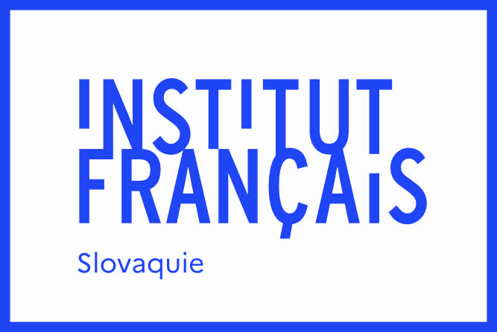 | 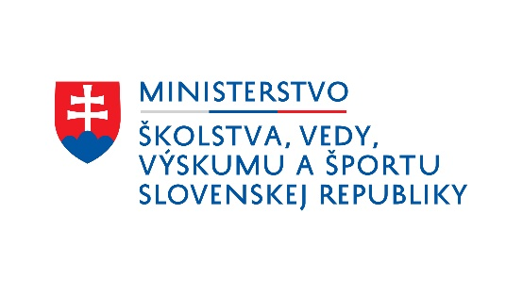

Scientific stays in France
2024 edition
information form

Last Name:
First Name:
Nationality:
Date of birth:
Phone number:
E-mail address:
Spoken languages and estimated CEFR level:
Postal address:

- I give my consent for the Academic and Scientific Service of the French Embassy in Slovakia to process my data and transmit them to its partners (CampusFrance, Ministry of Education of the Slovak Republic and Slovak Academic Information Agency) in order to select the beneficiaries of its scholarship program, to organize their study trips and, if a scholarship is awarded to them, to ensure their implementation
- I give my consent for the University and Scientific Service of the French Embassy in Slovakia to register my details and to use them for the purpose of sending me information concerning studies in France and French-Slovak university cooperation.
Date: Signature:

